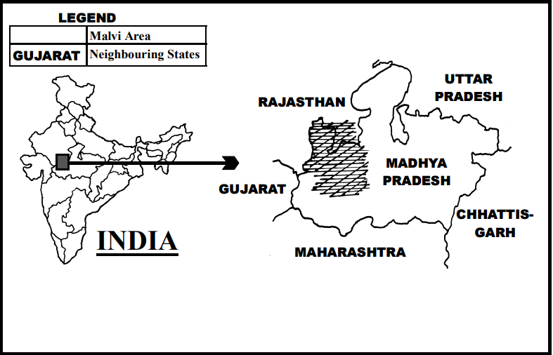

Figure 1.1.1.1 Malwa region

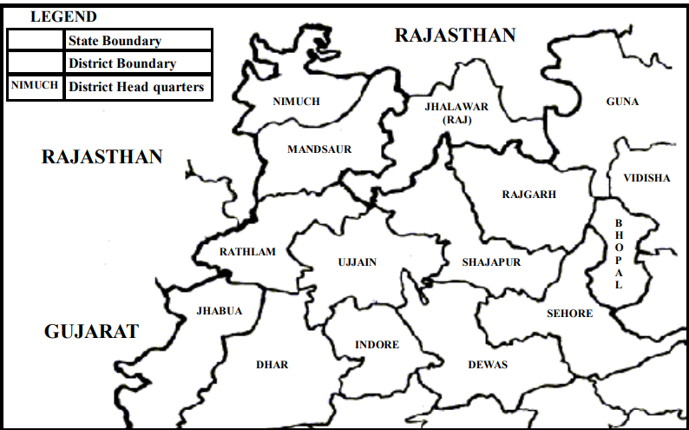

Figure 1.1.1.2 Malwa Region

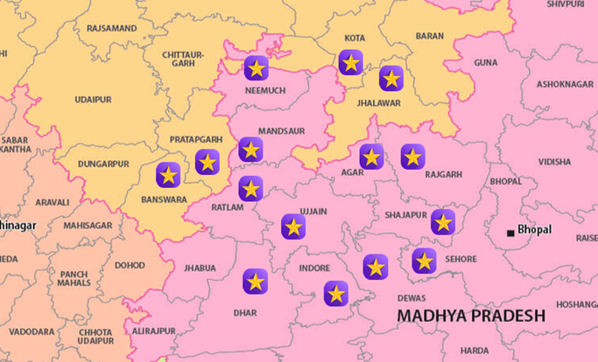

|  |  |  |
| --- | --- | --- |
| **District** | **Dialect** | **Tahsils** |
| RAJGARH | Umadwadi | rajgarh, khilchipur, biaora, sarangpur, narsinghgarh, zirapur, pachore, khujner, and suthaliya |
| MANDSAUR | Sondhwadi | Bhanpura, Daloda, Garoth, Malhargarh, Mandsaur,Shamgarh  Sitamau, Suwasra |
| NEEMUCH | Rajwadi Malvi | Neemuch Rural, Neemuch Urban, Jiran, Manasa, Rampura, Jawad, and Singoli. |
| RATLAM | Bhili Malvi ( influenced by local dialects)+Rajwadi | Ratlam-City, Ratlam-Rural, Sailana, Bajna, Raoti, Jaora,Piploda, A lot, Tal, Namli |
| UJJAIN | Ujjaini (Malvi Proper) | Ujjain Urban, Ujjain Rural, Ujjain Kothi Mahal, Ghatiya, Badnagar, Mahidpur, Nagda-Khachrod, Tarana, Jharda, Makdon, and Khachrod. |
| AGAR | Sondhwadi Malvi | Agar, Badod, Susner, and Nalkheda |
| SHAJAPUR | Sondhwadi | Shajapur, Shujalpur, Kalapipal Mandi, Gulana, Mohan Barodia, Awantipur Barodiya, and Polay Kalan |
| DEWAS | Adarsh Malvi | Dewas, Sonkatch, Bagli, Kannod, Tonk-Khurd, Khategaon, Satwas, Hatpipliya, and Udainagar. |
| SEHORE | Adarsh Malvi | Sehore Urban, Sehore Rural, Shyampur, Ashta, Jawar, Ichhawar, Bhairunda (Nasrullaganj), Budni, and Rehti. |
| DHAR | Adarsh Malvi | Dhar, Badnawar, Dharampuri, Sardarpur, Manawar, Kukshi, Dahi, and Gandhwani |
| **JHALAWAR (Raj)** | Sondhwadi | Aklera, Asnawar, Gangdhar, Jhalrapatan, Khanpur, Manoharthana, Pachpahar, Pirawa, Sunel, Raipur, Bakani, and Dag |
| **KOTA (Raj)** | Kota Malvi (variation influenced by local culture) | Ladpura, Digod, Pipalda, Ramganjmandi, Sangod and Kanwas |
| **PRATAPGARH (Raj)** | Rajwadi Malvi (local variations) | Pratapgarh, Kunda, Lalganj, Patti, and Raniganj |
| **BANSWARA (Raj)** | Bhili Malvi (with tribal influences) | Banswara, Garhi, Ghatol, Bagidora, and Kushalgarh |

Malwa Region Districts

**1) Ujjaini** is spoken in the area of Ujjain, Dewas, Indore, Sehore, northern Dhar, and southern Shajapur districts of MP. Ujjain was the capital of the Avanthi kingdom.

**2)** **Rajwadi** is found in Nimuch, Mandsaur, Rathlam, and some parts of Indore districts of MP. The people of this area prefer to call their language Malvi rather than Rajwadi. Since the Rajaputana kings were previously ruling the Mewad kingdom (including the region of Chittaurgarh and Banswara in Rajasthan and Mandsaur, Rathlam, and Nimuch in MP), the Malvi in this area was influenced by Rajasthani dialects and so it came to be called Rajwadi or Rangari.

**3)** **Umadwadi** is spoken in Rajgarh district of MP. The kings who formerly ruled in this area were Umads, a clan of Rajputs, and therefore this dialect of Malvi became known as Umadwadi.

**4) Sondhwadi** is spoken in Jhalawar district of Rajasthan and in northern Ujjain, north-western Shajapur, eastern Mandsaur, and western Rajgarh districts of MP. Since the region of Jhalawar district of Rajasthan and part of Mandsaur district of MP (between two Kalasindh rivers) was ruled by Sondhia kings (Sondhia being one of the Rajput

* + 1. **Malvi Speakers**

.**As per the latest published data in Census of 2001**,

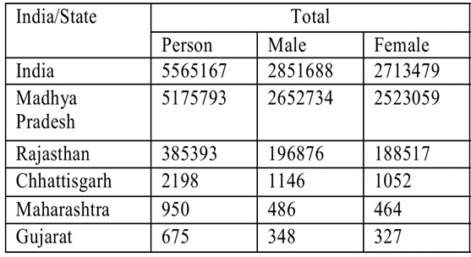

Total Malwa Speakers

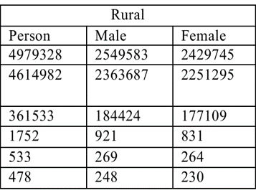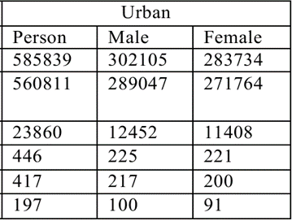

Urban Speakers

Rural Speakers

**According to the 2011 Census of India, the Malvi language ranked 24th among the mother tongues spoken by over 1 million people in the country.** With a total of 5,565,167 speakers, **Malvi represents approximately 0.43% of India's total population**.

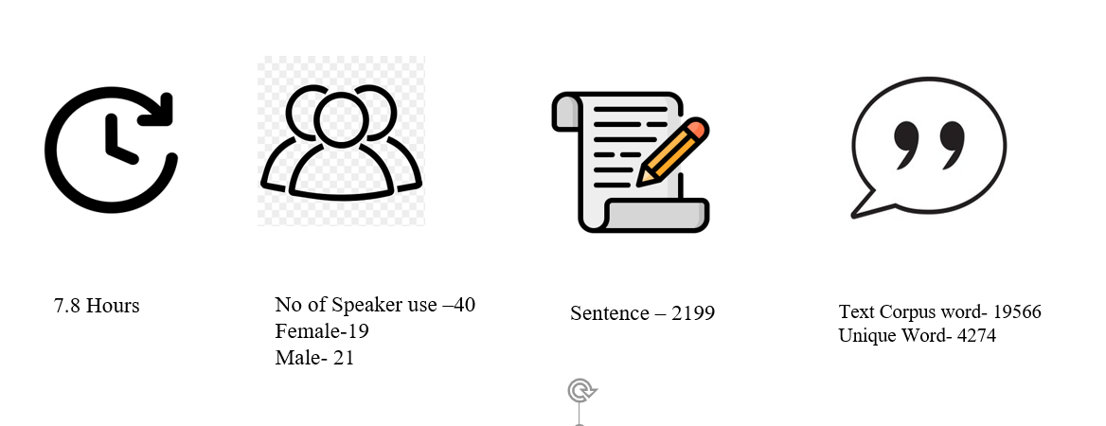

|  |  |
| --- | --- |
| **malvi** | **अबे का जमाना में सरकारी नौकरी लगनो मतलब दादा सुन्ना को खजणो मिलनो जेसो हो गयो है** |
| **hindi** | **अब के समय में सरकारी नौकरी लगना मतलब दादा-दादी के समय में खजाना मिलने जैसा हो गया है** |
|  | म्हारे या बताओ कांदा वाला ने पैसा दालीया की नि दलीया अभी तक आठ दन से तो आजकल आजकल क़रीरियो हूँ म्हारा घरे जाऊ वा तो कई तन्दुरा ले जाऊ वा साथै |
|  |  |
|  | तमारे तो हर बार बहानो ही चा म्हारे नि लेजाबा को तम तो हसाहि ही करो अब देखजो तम अब कुआ पे जाबा की बात आगि नि तो हूँ भी हसाहि करुवा |
|  |  |
|  | पानी नी पड़े जलंग अपन तो गऊ काटी ला नि तो फिर सगला गऊ बिटमई जायगा तो खाबा का तो लाला पड़ जायगा |
|  |  |
|  | **अरि जीजी इ चार बेलड़ा हे गलकिया का अनका चक्कर में हुन म्हारी साडी सोयाबीन सूखा दू अने निन्दु खोडू वाकी जगह के अणि गलकिया होर में लगियो रु** |
|  |  |
|  | **एसा में हमारी कोसिस होनी चइये के सब जगा की बोलीहुन ने संस्कृति हुन बची रे ने ऊना के ऊछेरवा का सारू सब हिली मिली के कोसिस करा** |
|  |  |

**Malwi language:**

Malvi is a regional language spoken in the northwestern part of MP and in Jhalawar district of Rajasthan. It is functioning as a language for intra-group and inter-group communication. The language name is Malvi because it is spoken in the region of Malwa. It has alternative names such as Malwada, Mallow, and Ujjaini, and alternate spellings such as Malwi and Malavi. Malvi is a language of the Indo-European, Indo-Iranian, IndoAryan subfamily, Central group (Gordon 2005:374). It was previously considered that Malvi is a dialect of South Rajasthani (Grierson 1907). Grierson further suggested, ‘Nimadi is really a form of Malvi, but it has such marked peculiarities of its own that it must be considered separately’ (Grierson 1907:60). According to Joshi (1999:cover page), Malvi is not a dialect of South Rajasthani nor Eastern Hindi, but instead comes under Western Hindi and as a language has its own identity. The Malvi language is said to be a direct descendant of ‘Avanthi Prakrith’3 of the mid-Indo-Aryan Family. Malvi is surrounded by different languages and dialects of Gujarati, Rajasthani, Hindi, and Marathi. Along its boundaries are: to the northwest, Mewari to the southwest, Gujarati to the north, the Jaipuri dialect of Rajasthani to the east, the Bundeli dialect of western Hindi to the south, Nimadi and the Khandeshi dialect of Marathi

Within the Malvi language area, there are various ‘islands’ of Bhili and Gondi dialects of MP. Over the ages Malvi has fallen under the influence of the main neighbouring languages such as Hindi, Marathi, and Gujarati. For example, originally Malvi had a counting system of numbers up to twenty, and then for twenty they would say ‘kozi’. After twenty, they would say ‘one kozi’, ‘two kozi’, etc. Perhaps because of the influence of Hindi, this Malvi numbering system is no longer much in use. 1.4.2 Dialects Malvi has its own identity, literature, and dialects. The Ethnologue lists the following as dialects of Malvi: Bachadi, Bhoyari, Dholewari, Hoshangabad, Jamral, Katiyai, Malvi Proper, Patvi, Rangari, Rangri, and Sondhwari (Gordon 2005:374). However, regional scholars consider the four major dialects of Malvi to be Ujjaini (also called Avanthika or Malvi Proper), Rajwadi, Umadwadi, and Sondhwadi. 1) Ujjaini is spoken in the area of Ujjain, Dewas, Indore, Sehore, northern Dhar, and southern Shajapur districts of MP. Ujjain was the capital of the Avanthi kingdom. 2) Rajwadi is found in Nimuch, Mandsaur, Rathlam, and some parts of Indore districts of MP. The people of this area prefer to call their language Malvi rather than Rajwadi. Since the Rajaputana kings were previously ruling the Mewad kingdom (including the region of Chittaurgarh and Banswara in Rajasthan and Mandsaur, Rathlam, and Nimuch in MP), the Malvi in this area was influenced by Rajasthani dialects and so it came to be called Rajwadi or Rangari. 3) Umadwadi is spoken in Rajgarh district of MP. The kings who formerly ruled in this area were Umads, a clan of Rajputs, and therefore this dialect of Malvi became known as Umadwadi. 4) Sondhwadi is spoken in Jhalawar district of Rajasthan and in northern Ujjain, north-western Shajapur, eastern Mandsaur, and western Rajgarh districts of MP. Since the region of Jhalawar district of Rajasthan and part of Mandsaur district of MP (between two Kalasindh rivers) was ruled by Sondhia kings (Sondhia being one of the Rajput clans), and since Sondhias are in the majority in this area at present, this dialect is referred to as Sondhwadi.

Language development Radio, television, and audio-video materials All India Radio had a daily broadcast in Malvi about agriculture from its Indore station, but it was reduced to two days a week because the response from the people was limited. However, there are some radio and television programmes in Malvi about culture and folk songs. There are some religious and cultural audio and videocassettes also available in Malvi. Written materials Once a week some articles, stories, poems, and cultural information are published in Malvi in a newspaper called Nayi Duniya. There are some storybooks also available in Malvi. There are a number of theses about Malvi history, language, and people available in universities of this area. There is a Malvi-Hindi dictionary written and compiled by Dr. Prahaladchandra Joshi and published by Sarthak Prakashan, New Delhi. There is also a Malvi self-study book written by Dr. Joshi and published by Sri Kaveri Research Institute, Ujjain. There are some religious materials available as well. 16 1.5 Purpose and goals The purpose of this sociolinguistic research among the Malvi-speaking people was to assess the need for a language programme of literature development and literacy work in the mother tongue. If such a need was found, a subsequent purpose was to determine whether there is a central variety of Malvi in which language development could be carried out. To fulfill the purpose, the following goals were formulated: 1) To clarify the geographic boundaries of the Malvi-speaking area. Tools: Informal interviews and written sources 2) To investigate the dialects of Malvi and their relationships to one another. Tools: Wordlists and Recorded Text Testing (RTT) 3) To investigate the levels of bilingualism in Hindi among Malvi speakers. Tools: Questionnaires, Sentence Repetition Testing (SRT), and observations 4) To investigate the language use of Malvi speakers, their language attitudes (towards their own Malvi variety, towards other Malvi varieties, and towards Hindi), and to assess the vitality of their mother tongue. Tools: Questionnaires and observations 5) To find out about the literature already available in Malvi. Tools: Informal interviews The Malvi survey was focussed on three primary areas of study. These were a dialect area study; a bilingualism study; and a language use, attitudes, and vitality study. Dialect area study Lexical similarity study There was an attempt to the levels of lexical variation within the Malvi language. This was done through the study of lexical similarity between wordlists collected from locations throughout the Malvi-speaking region. Dialect intelligibility study It was reported that differences exist between the four main dialects of the Malvi language. To find out intelligibility levels among selected Malvi varieties, Recorded Text Testing (RTT) was used. After each RTT, a brief questionnaire was administered in order to find out the attitudes of subjects towards the Malvi varieties that were tested. Bilingualism study The Hindi Sentence Repetition Test (SRT) was used to assess community levels of bilingualism in Hindi among Malvi speakers. Questionnaires and observation were also useful to help find out bilingualism levels in Hindi. Language use, attitudes, and vitality study Through questionnaires administered to Malvi speakers in several different locations, the researchers made an attempt to assess the language use and attitudes of Malvi-speaking people. The domains of life in which the heart language as well as other languages are reportedly spoken were studied. There was also an attempt to find out the attitudes of Malvi speakers towards their own Malvi variety, towards other Malvi varieties, and towards Hindi. The vitality of the language was assessed as well. 17 2 Dialect Areas One of the primary goals of this survey was to investigate the relationships among different speech varieties within Malvi. To accomplish this objective, various tools were used such as lexical similarity comparisons from wordlists to assess the relationship between various speech varieties and Recorded Text Testing to test the intelligibility of one dialect to speakers of other dialects. Lexical similarity and dialect intelligibility are discussed in detail in this chapter. 2.1 Lexical similarity 2.1.1 Procedures One method of gauging the relationship among speech varieties is to compare the degree of similarity in their vocabularies. This is referred to as lexical similarity. Speakers of varieties that have more terms in common (thus a higher percentage of lexical similarity) generally, though not always, understand one another better than do speakers of varieties that have fewer terms in common. Since only elicited words and simple verb constructions are analysed by this method, lexical similarity comparisons alone cannot indicate how well certain speech communities understand one another. It can, however, assist in obtaining a broad perspective of the relationships among speech varieties and give support for results using more sophisticated testing methods, such as comprehension studies. For a fuller description of counting procedures used in determining lexical similarity, refer to Appendix B. The tool used for determining lexical similarity in this survey was a 210-item wordlist, consisting of items of basic vocabulary, which has been standardised and contextualised for use in sociolinguistic surveys of this type in South Asia. The elicited words were transcribed using the International Phonetic Alphabet (IPA) shown in Appendix A. Each wordlist was compared with every other wordlist, item by item, to determine whether they were phonetically similar. Those words that were judged similar were grouped together. Once the entire wordlist was evaluated, the total number of word pair similarities was tallied. The total number of items compared and multiplied by 100, giving what is called the lexical similarity percentage, then divided this amount. For example, if between two wordlist sites, a total of 207 items were compared and 176 of these word pairs were deemed similar, then the lexical similarity percentage would be 85 percent. This process of evaluation was carried out according to standards set forth in Blair (1990:30–33) and facilitated through the use of a computer program called WordSurv (Wimbish 1989). This program is designed to quickly perform the counting of word pair similarities and to calculate the lexical similarity percentage between each pair of wordlist sites. 2.1.2 Site selection In order to see a broad picture of the Malvi language, thirty-eight wordlists were compared in the lexical similarity study. Thirty wordlists were collected during this 18 survey, representing the main people groups living in this region. The Malvi wordlists were collected based on the following criteria: Geographic spread Reported dialect variation Urban and rural representation Caste and tribe representation Wordlists from additional languages/dialects spoken in Malwa and in neighbouring regions were also included in this lexical similarity study. Figure 5 summarises the speech variety, location, and origin of the wordlists utilised in this study. The table is ordered according to the speech variety, state, and district in which the wordlist located. Further information about each wordlist and its informant as well as phonetic transcriptions of the wordlists are given in Appendix B. Figure 6 displays the lexical similarity percentages matrix for all speech varieties compared. Wordlists are arranged so that all Malvi varieties are grouped together while other speech varieties are grouped separately. Wordlists have also been ordered from generally higher to lower similarity percentages.